**Electrical Circuit**

* An electrical circuit is nothing more than a collection of transistors, capacitors, diodes, and other components, including logic gates.
* Each component has its own set of requirements.
* And it is through this that we learn about currents and voltages.
* A path through which electrons from a voltage or current source flow is known as an electrical circuit.

**LINEAR ALGEBRA IN ELECTRICAL CIRCUITS**

* Electrical engineers appear to be the most frequent users of linear algebra.
* The concept of linear algebra is introduced whenever there is a system of linear equations.
* Various electrical circuit solutions, such as Kirchhoff's law and Ohm's law, are based on linear algebra.
* The concept of linear algebra must be introduced in order to solve various linear equations.

In an electrical network, it is possible to determine the amount of current in each branch in terms of resistance and the voltages.

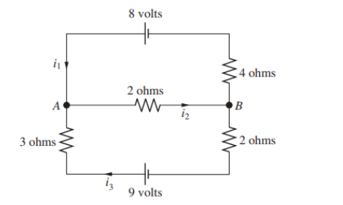

The symbol in the figure have the following meanings:

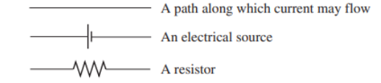

The electrical source is usually a battery with a voltage that drives a charge and produces a current. The current will flow out from the terminal of the battery that is represented by longer vertical line. The resistances are measured in ohms. The letters represent nodes and the i ‘s represents the currents between the nodes. The currents are measured in amperes(A). The arrow shows the direction of the currents. If, however, one of the currents, say, i2, turns out to be negative, this would mean that the current along the branch is in the direction oppoosite that of the arrow.

To determine the currents, the following rules are used:

**Kirchhoff’s Laws :**

1. At every node the sum of the incoming currents equal to the sum of the outgoing currents.
2. Around every closed loop, the algebric sum of the sum of the voltage gains must equal the algebric sum of the voltage drops.

The voltage drops E for each resistor are given by Ohm’s law:

E = iR

Let us find the currents in network pictured in figure. From the first law we have

i1 - i2 + i3 = 0 (node A)

-i1 + i2 – i3 = 0 (node B)

By the second law,

4i1 + 2i2 = 8

2i2 + 5i3 = 9

The network can be represented by the augmented matrix

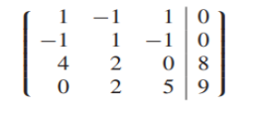

The matrix is easily reduced to the row echelon form

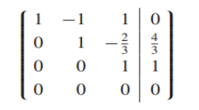

By solving the following we get

i1 = 1 A

i2 = 2 A

i3= 1 A